Finding Apolonia
A case study in assembling Direct, Indirect and Negative Evidence in the search for her parents
By Jillette Torre Leon Guerrero

Introduction
Proving the parentage of individuals born in Guam during the 1800s is difficult, and in some cases, appears impossible. Finding any written documentation for those born during this period is a challenging endeavor. This is because much of the written documentation for this period did not survive. Guam’s turbulent history, the tropical climate and the devastation of World War II are responsible for the dearth of information., This presents a challenge to genealogists and requires them to use creative strategies to assemble evidence in support of their research. Unless a hidden cache of historical documents is found to bridge this gap, this will continue to confound genealogists and historians for years to come.

In Guam, many families do not know much about their ancestors that lived in the early 1800s. One significant event that may have contributed to this situation was the worldwide influenza pandemic in 1918-19. Brought to Guam onboard the military transport ship the USS Logan, the “Spanish Flu” killed over 6% of the island population. The very young and the elderly were especially vulnerable. Because of the high rate of mortality in the elderly, it has been said that over 80% of those who spoke Spanish perished because of the epidemic. While this event brought an abrupt halt to the use of the Spanish language on Guam, it is also believed to have hindered the transmission of family histories from one generation to the next. For today’s elderly, it is not uncommon for Guam residents to not know who their great grandparents were. For those that do, they know very little about their lives. This was the case with Apolonia Ada.

Apolonia Ada
Apolonia was born about 1861-3. She gave birth to a daughter named “Josefa” around 1885 when she was 22 years old. The father of Josefa is unknown. She later married Juan de la Torre y Acosta and bore him four children: Soledad, Vicenta, Juan and Felicita. She died between 1941-1944. She has been associated with several surnames including Ada, Cruz, Reyes, and Torre. Her surviving grandchildren know very little else about her. With this in mind, a search for written evidence of Apolonia Ada was launched with the hopes of uncovering her family origins.

Research Objective
The objective of the research was to determine who Apolonia’s parents were. The first place to start was to investigate the various names associated with her. In order to understand the significance of her name, a review of the naming traditions in Guam is in order.

What’s in a Name? Naming traditions in Guam
Naming traditions in Guam are confusing. The indigenous people of Guam, the Chamorro people, did not traditionally have surnames. When the Spanish arrived in 1668 and began baptizing the population, Chamorros were given Christian first names and their Chamorro names became their last name. This meant that siblings all had different last names.

During the Spanish period, the Hispanic naming system was followed. Wives did not take their husbands surname. Children many times were given composite names. Jose Maria for a male would be a composite first name. Maria Angelica would be a composite first name for a girl. This creates problems when searching for individuals as either name could be recorded. Hispanic surnames were compound names comprised of their mother and father’s surnames. When both the maternal and paternal names were used, they were conjoined with the conjunction “y”. In the Spanish tradition the paternal name came first followed by the maternal name. The Portuguese tradition was the opposite. The maternal name came second and the paternal name last. In cases where parents weren’t married, children usually carried their mother’s surname (s).

Guam was ceded to the United States in 1898. Over time, the Americans introduced a different naming pattern where the maternal surname became the middle name and the paternal surname became the last name. In some cases compound surnames like de Leon Guerrero were shortened to “de Leon” or “Guerrero”. In many cases the particles: de, de la, de los and the copulative conjunction “y” were lost. During this period many were known to change their names to make it easier to get employment with the American administration. Some used their maternal names as a last name instead of their paternal name. Some were known to completely change their name and siblings in one family were known to each spell their names differently. This can be attributed to the Naval Governments order that all adults learn to write their names. The law stipulated that, “any citizen may procure from the Government a suitable sample of his or her written name for use as a copy to be imitated in practice and instruction.”

Apolonia in the Historical Record
There is much confusion about Apolonia’s name. Her name has been recorded as “Apolonia Ada de la Cruz”, “Apolonia Reyes Ada” and “Apolonia Ada”.,,

The earliest instance of Apolonia is found in the 1897 Spanish Census. According to this document Apolonia was born about 1863. She is found in the household of Francisco de la Cruz along with 7 others. Although the document indicates that all are the children of Francisco de la Cruz, a widower, the two youngest are known to be Apolonia’s children.

The next document that we find Apolonia recorded in is the 1920 Guam Church Census. She appears as Apolonia Ada and is now married to Juan de la Torre Acosta (61). This is Juan’s second marriage as he is listed as the widower of Vicenta Borja. Recorded along with the couple are their children: Soleded (26), Vicenta (23), Juan (20) and Felicitias (18). Josefa, (31) is also recorded as the natural child of Apolonia. Josefa and Soledad were first recorded along with Apolonia in the 1897 Spanish census in the household of Francisco de la Cruz. From this we learn that Soledad was born prior to the marriage of Juan and Apolonia. The father of Josefa is unknown.

The 1920 U.S. Census for the Island of Guam records the same family as such: Juan A La Torre (60), Apolonia A. La Torre (58), Josefa (34), Soledad (22), Vicenta (20), Juan (18), Felicitias (16). All are recorded with the surname “La Torre”.

Table 1: Apolonia in Historical Records
Name | Age | Date | Head of Household/Document | Others | Source
Apolonia  [No indication of surname but assumed to be de la Cruz] | 34 | 1897 | Francisco de la Cruz (67)  [Father of Apolonia] | Children of Head of Household:  Vicente (36)  Jose (24)  Tomas (20)  Manuel (17)  Ana (18)  Josefa (12)  Soledad (8) | 1897 Spanish Census  page 99-78b
Apolonia Ada | 59 | 1920 | Juan de la Torre Acosta (61) | Children:  Soledad (26)  Vicenta (23)  Juan (20)  Felicitas (18)  Josefa (31) | 1920 Guam Church Census  page 103
Apolonia A. La Torre | 58 | 1920 | Juan A. La Torre (60) | Children:  Soledad (22)  Vicenta (20)  Juan (18),  Felicitas (16)  Josefa (32) | 1920 U.S. Census  San Vitores Street  Agaña City  The Island of Guam
Apolonia A. de la Torre | 54  [67] | 1930 | Juan Acosta de la Torre (71) | Children:  Soledad (35)  Felicita (26) | 1930 U.S. Census  Machananao Barrio,  The Island of Guam
Apolonia A. Torre | 76 | 1940 | Juan A. Torre (80) | Stepdaughter of head of household:  Josefa Ada (49)  “Servant?”  Teresita Cruz (10) | 1940 U.S. Census  Barrio San Antonio  Agaña,  The Island of Guam
Appollonia Reyes Ada |  | 1988 | Death Announcement of  Vicenta Ada Torre Leon Guerrero | Family members in announcement:  Juan Acosta Torre  Josefa Ada Reyes  Felicta Torre Munoz  Soledad Ada Torre  Juan Ada Torre | Pacific Daily News  10/15/1988  page 10
Apolonia Reyes Ada |  | 2003 | Death Announcement of  Felicita Torre Munoz | Family members in announcement:  Juan Acosta Torre  Josefa Ada Torre  Soledad Ada Torre  Vicenta Torre Leon Guerrero  Juan Ada Torre | Pacific Daily News  9/10/2003  page 25
Apolonia Ada Cruz |  | 2009 | De la Torre Family Tree  [indicates that Apolonia’s parents are  Fabian de la Cruz and Juliana Ada] | Juan Acosta de la Torre  Soledad Ada Torre  Vicenta Ada Torre  Juan Ada Torre  Felicita Ada Torre, Josefa Ada | Tronkon y Familian  Francisco de la Torre  yan Maria Acosta  by Joaquin Torre  23 Oct. 2009

In the 1930 U.S. Census Juan Acosta de la Torre (71) is recorded with Apolonia A. de la Torre (54), Soledad (35), and Felicita (26) in Machananao. It is known that Vicenta and Juan had married by this time and no longer lived with the family. Josefa is listed as the head of a household in Agaña. Many families had two households during this period. One located in the capital city of Agaña, and another in a rural area. This was the case with the de la Torre family. It appears that Josefa [recorded as Josefa A. Torre] kept the house in Agaña while the rest of the family was with Juan and Apolonia in Machananao, where the family farm was located.

The 1940 U.S. Census records Apolonia A. Torre along with Juan A. Torre and her daughter, Josefa. Josefa Ada (49) is listed as stepdaughter to Juan. Another person, 10 year- old Teresita Cruz, is listed as “servant?” It is more likely that Teresita was a niece or granddaughter of Apolonia who was living with the elderly couple to help them out. A common practice in Guam at the time was that one daughter would remain single to live with and care for elderly parents. It appears that Josefa fulfilled this duty. In other cases young children (many times nieces and nephews) would live with extended family members to help out with household, farming or other duties that the family was involved in. The host family would take the children as their own and provide for their welfare and education.,

A search was conducted through the Guam News letter index for the period 1914 - 1921 and the Guam Judicial records index for the period 1807-1935. Neither mentions Apolonia Ada, Apolonia Cruz, Apolonia de la Cruz, Apolonia Reyes or Apolonia Torre or Apolonia de la Torre. ,

No death records for Apolonia were found. She died during the Japanese occupation of Guam [WWII] and the exact location of her last resting place is not known. During the war she lived in the household of Justo Torre Leon Guerrero, her grandson. He believes that she was buried on what is now federal land, and houses the U.S. Air Force base in Yigo, Guam. The area is restricted and access is prohibited. It is not known if the burials located there were moved to another location after the war.

Moving forward, the next place we find reference to Apolonia, is in the Guam People Data Cards as compiled by Anthropologist Jane H. Underwood between 1965-1992. She is simply listed Apolonia Ada and is found along with Juan Acosta de la Torre [who is incorrectly recorded as Juan Acosta de la Torres] and children: Josefa, Soledad, Juan, Vicenta and Felicita.

Another mention of Apolonia is found in the death and funeral announcements of two of her daughters, Vicenta and Felicita. Death announcements for her daughters Josefa and Soledad and son Juan were not found. Vicenta Ada Torre Leon Guerrero passed away in 1988. In her death announcement her mother is recorded as Appollonia Reyes Ada. In 2003, the death announcement of Felicita Torre Munoz, Apolonia Reyes Ada is listed as the mother of the decedent.,

This appears to be a mistake on the part of the funeral home that prepares the announcements for publication. The surviving grandchildren have no recollection of their grandmother being from the Reyes clan. There was an Ada family that married into the Reyes clan. Perhaps the drafter of the funeral announcements mistook this family for the family of Apolonia. All of the evidence gathered so far does not support a “Reyes,” as a viable option for Apolonia’s maternal line. A visit to the Ada funeral home revealed that all of the documents for the business prior to the 1990s had been destroyed.

Only one other item was found for Apolonia. It is a photo that is believed by the family to be of Apolonia and her two eldest daughters, Josefa and Soledad. It was originally published in an article entitled General Schroeder and American Rule in Guam by the Reverend Francis E. Price in the Independent Magazine in 1903. The caption of the photo reads, ‘Chamorro “Wash women”’. It was later published in a pictorial history of Guam in 1986. According to family members, it was incorrectly captioned and has created even more confusion about this ancestor. The caption reads, “These women, posing in front of their employer’s house, were nicknamed ‘Vicenta Eslau.’ They are, from left, Rosa, Dolores, and Victoria.” When the author of the book was contacted recently he could not remember where he obtained the photo or who identified those in the image. The photo in question was identified by Herbert and Emilie Johnston and given to the author of this study in 2010. Emilie was the first curator of the Micronesian Area Research Center’s photographic collection and Herbert was the grandson of Apolonia’s husband, Juan de la Torre y Acosta. They were both confident that the photo was of Apolonia and her eldest daughters. Unfortunately, both have passed on and we cannot confirm where they obtained the photo. When the photo is shown to the surviving grandchildren of Apolonia they all agree that they recognize Apolonia, Josefa and Soldedad. For this reason, we believe that the photo is a photo of Apolonia, Josefa and Soledad.

Although we have found no direct evidence for the birth name of Apolonia, we have assembled evidence that gives us some insight into Apolonia’s life.

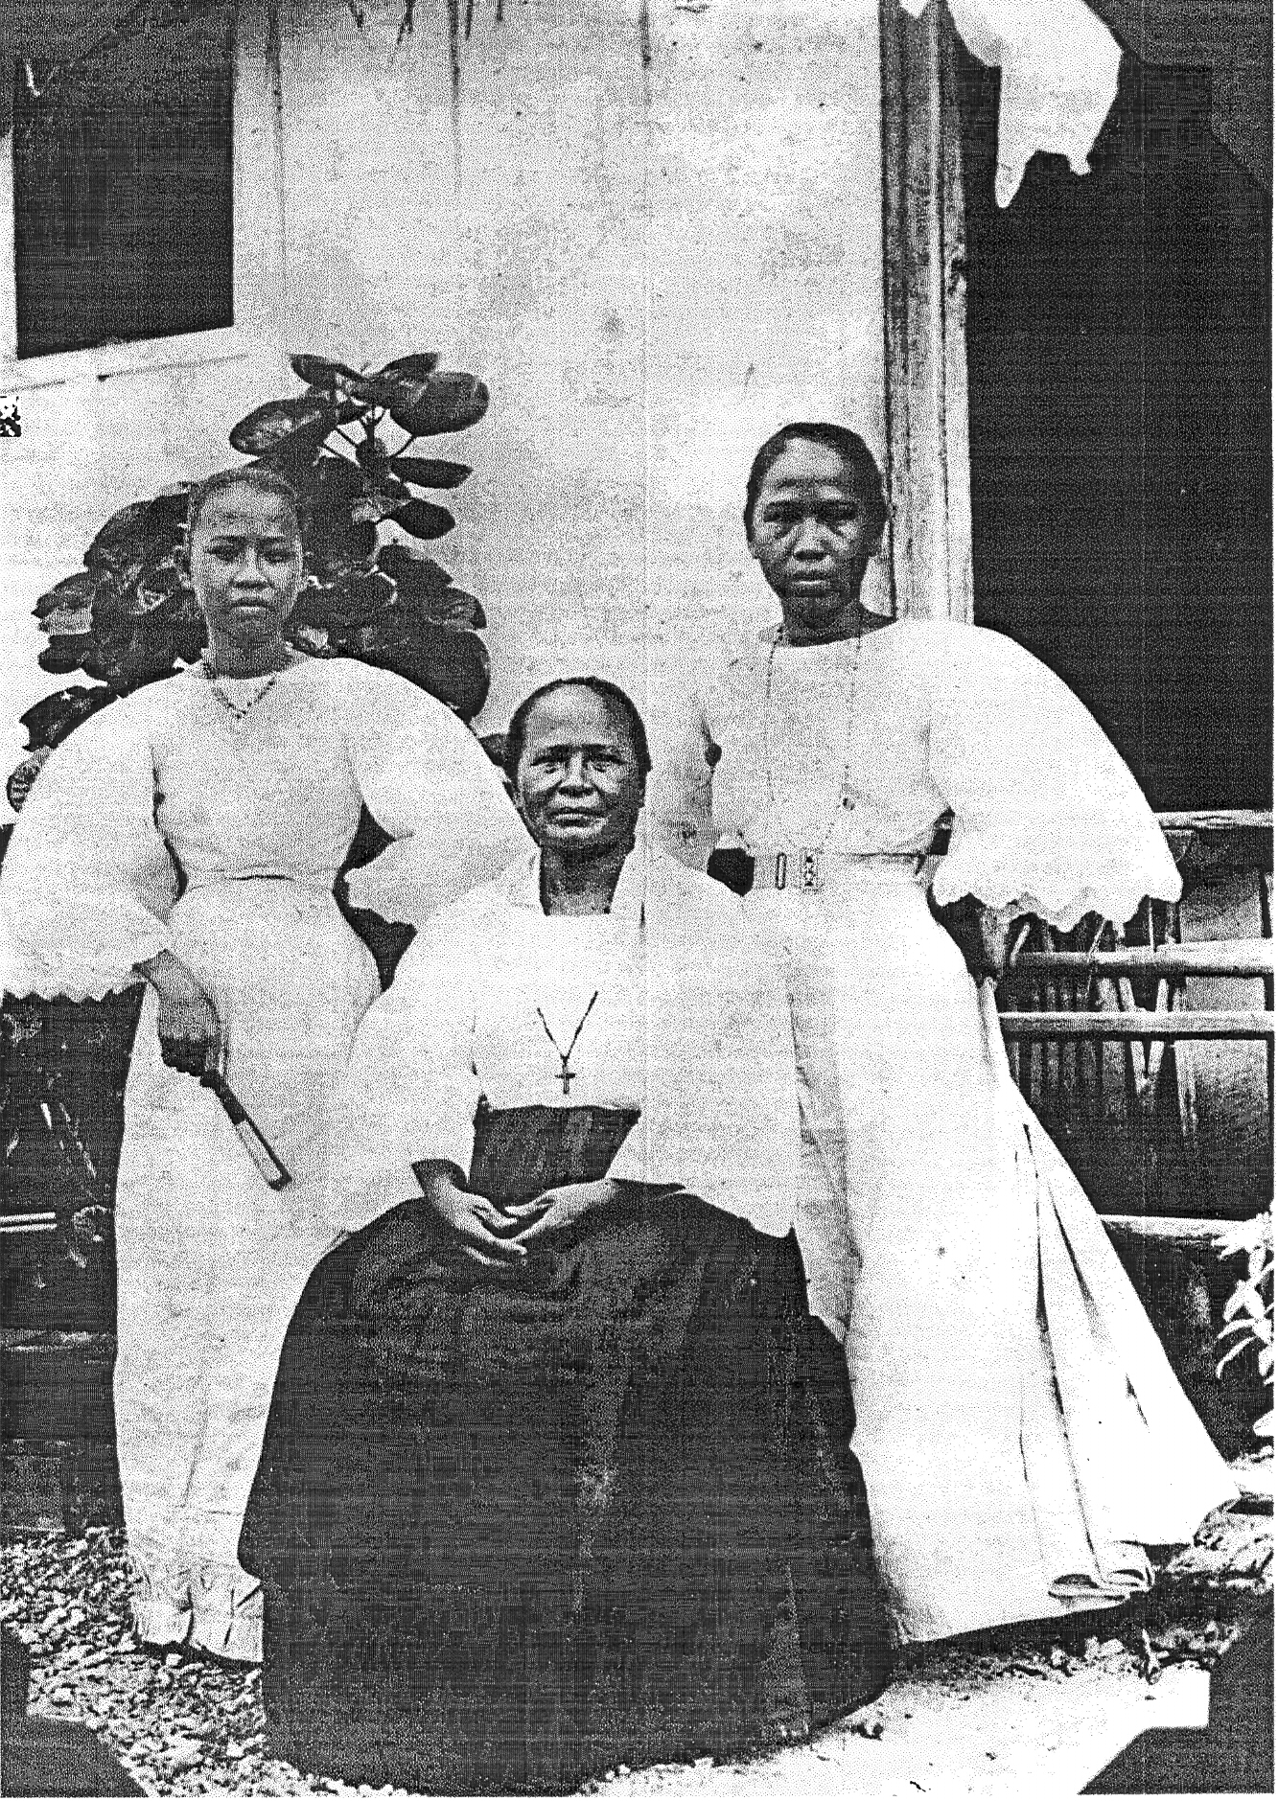

Image 1: This photo is reportedly of Apolonia Ada and her daughters Josefa and Soledad about 1903.

Fabian and Francisco de la Cruz
Numerous family trees published in recent years both online and in book form have indicated that Apolonia’s parents are Fabian de la Cruz and Juliana Ada. In many cases she is listed as Apolonia Ada Cruz. In this study, we could find no direct historical evidence of Fabian de la Cruz and Juliana Ada as Apolonia’s parents. In fact, many of these family trees have grouped the children of Francisco de la Cruz listed in the 1897 Spanish census incorrectly as the children of Fabian de la Cruz. It is possible that many of these were grouped based on the combination of the “Ada,” and “de la Cruz” surnames.

In order to shed some light on this situation we compared the families of Fabian de la Cruz and Francisco de la Cruz. [No other composite Cruz Ada families were found]

Table 2: Comparison of the Cruz Ada families
Fabian de la Cruz (64, widower)  1897 Census page 99-4a, | Francisco de la Cruz (67, widower)  1897 Census page 99-78b
Children | Children
Manuel (29) | Vicente (36)
Ana (25) | Jose (24)
Felipe (21) | Tomas (20)
Juan (20) | Manuel (17)
 | Ana (18)
Margarita de la Cruz (65 – sister?) | Apolonia (34)
Antonio de la Cruz (37 – nephew?) | Josefa (12, daughter of Apolonia)
 | Soledad (3, daughter of Apolonia)

In the 1897 Spanish census we find Fabian de la Cruz, a 64 year-old widower along with 4 children: Manuel (29), Ana (25) Felipe (21) and Juan (20). Margarita de la Cruz (65) is believed to be his unmarried sister and her son, Antonio (37). We find mention of Fabian next in the 1920 Church census as the father of Felipe de la Cruz Ada.

In the same census we have the children of 67 year-old widower, Francisco de la Cruz, as: Vicente (36), Apolonia (34), Jose (24), Tomas (20), Manuel (17), and Ana (18). Incorrectly classified as Francisco’s children, are Josefa (12) and Soledad (3), who we know are the children of Apolonia.

From the information in Table 2 we can see that Apolonia, at age 34, fits better age wise into the family of Francisco de la Cruz.

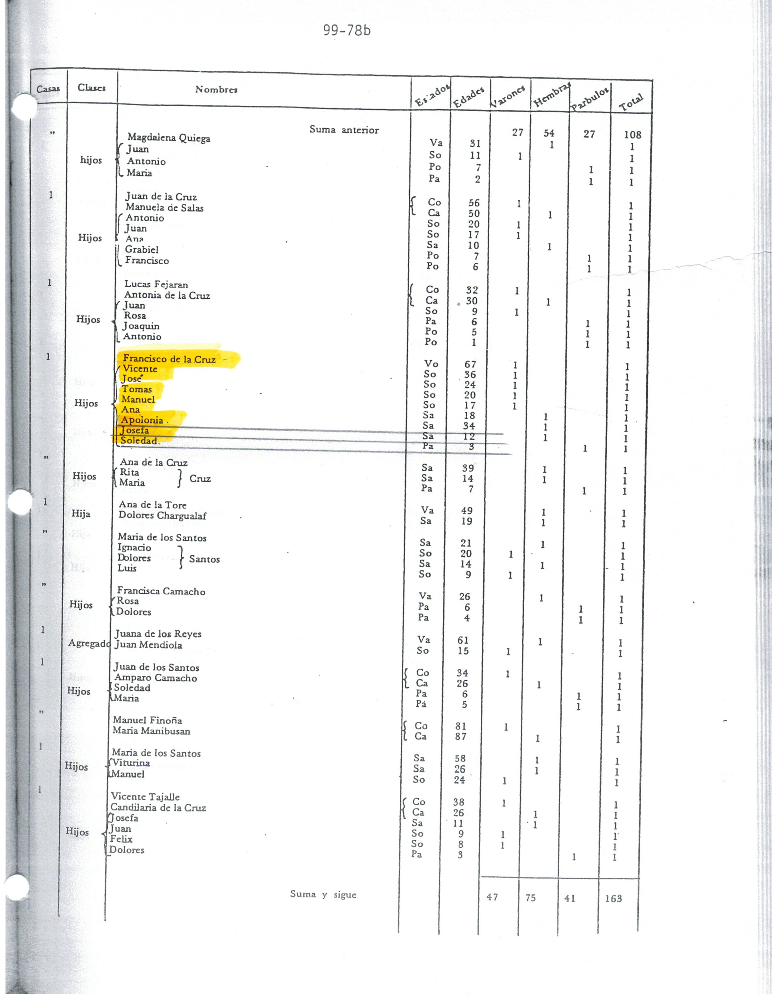
Francisco de la Cruz is recorded as the father of Apolonia in the earliest document. He is a widower and there is no indication of the name of his wife. The census does not reveal his maternal surname. While Apolonia is listed as his daughter, there is no indication in the document as to the children’s maternal surname. It can be assumed that their paternal surname is “de la Cruz” since Francisco is listed as their father. But this may not be the case
if he did not marry their mother. In that case, they would carry their mother’s surname.

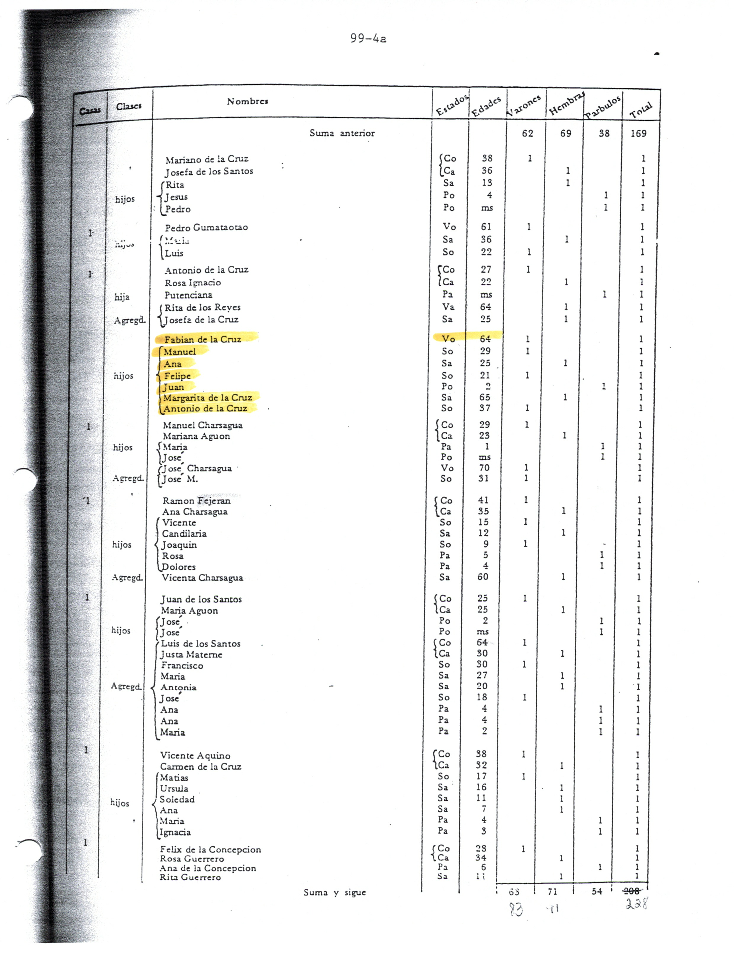

The 1897 Spanish Census records both Fabian and Francisco de la Cruz with their families

The judicial records index was searched for Francisco de la Cruz. Prenuptial agreements were often used during this time period to ensure that property owned by each spouse prior to marriage, did not become community property. If a prenuptial agreement were found it would reveal the wife of Francisco de la Cruz. The search revealed 175 entries. None were for prenuptial agreements. Most of the documents were for Francisco de la Cruz y Martinez. Also listed was Francisco de la Cruz y Benavente, and Francisco de la Cruz y Salas. There were also several recorded as only Francisco de la Cruz. From past experience, each document would have to be reviewed in order to determine if there was any mention of other family members of the Francisco de la Cruz noted in the index. This is painstaking work as most of the documents are in Spanish and require translation. Because of time limitations this was not pursued.

Apolonia’s Siblings
In order to determine if the children’s mother was an “Ada” we searched for Francisco’s children in the historical record with the combination surname of Cruz and Ada. If they followed the naming patterns of the time, their compound surname would have been either de la Cruz Ada or Ada Cruz [if they followed the American naming pattern.] We searched for both de la Cruz and just Cruz since the practice of dropping the preposition was common at the time. If Francisco did not marry the children’s mother, then “Ada” would be their last name. Because the Ada family was very small, all instances of “Ada” were checked. The search revealed candidates for all of Apolonia’s siblings. All carried the Cruz Ada or Ada Cruz name.

During this period the 1897 Spanish census, the Guam judicial records and the 1920 Church census used the Spanish naming pattern while all U.S. census documents used the American naming pattern. It is interesting that even the early American judicial records used the Spanish naming pattern. This is very confusing for the researcher.

Vicente de la Cruz y Ada was found in several judicial records for the years 1901 and 1903. We also found him referenced in the 1920 Church census as the late husband of Basilia Camacho Taitano. Because he died before 1920 we were not able to find any further references for him in the historical record and could not confirm his age. For this reason it is uncertain if this is the brother of Apolonia. While it appears plausible that this is Apolonia’s brother, we cannot be certain. The fact that on the same page of the census we find Manuel Cruz Ada [Spanish naming pattern with the “de la” omitted] of the same age as Apolonia’s brother seems to add credence to the possibility. Manuel is married to Maria Aflague. We also find Manuel listed as Manuel A. Cruz [American naming pattern] in the 1920 U.S. census married to Maria A. Cruz. They are listed along with six children. This is the same person and appears to be Apolonia’s brother. Manuel, the son of Fabian de la Cruz, was not found in the church census but he was found in the 1920 U.S. census as Manuel A. Cruz. He is the same age as Fabian’s son Manuel. He is enumerated along with his wife, Ana M. and two children.

Jose and Tomas Cruz Ada, also appear in the 1920 Church census, both are the right age to be Apolonia’s brothers. According to this document, Jose married Candelaria de la Torre Acosta, the sister of Juan de la Torre Acosta who married Vicenta Ada Torre, Apolonia’s daughter. Jose is also found in the 1920 U.S. Census listed along with his wife Candalaria T. and 5 children. This finding establishes a close relationship between the de la Torre Acosta and the de la Cruz families.

Tomas also was found in the 1920 Church census and the U.S. census. In the U.S. census he is listed alongside his wife, Ana Leon Guerrero, who was also recorded with him in the 1920 Church census. The couple had 7 children. This is another indication of allied families as Apolonia’s daughter, Vicenta, would also marry into the Leon Guerrero family.

Ana de la Cruz Ada was found in the 1920 church census and was a good candidate to be Apolonia’s sister. She is listed along with Ignacio Cruz Manibusan and five children. Unfortunately her age was not given. According to the census Ana’s eldest child was born in 1908. The mean age for women to marry in Guam at the time was 21.5 years old. If she married at 22, it is possible that she gave birth to her first child in 1908. Fabian de la Cruz also had a daughter named Ana. She was 7 years older than Apolonia’s sister, Ana. This means that both were of childbearing age in 1908. This makes it difficult to determine which Ana is mentioned in the census.

Because Apolonia’s siblings appeared to have carried the Cruz Ada/Ada Cruz name, and because there were only two families in the historical documentation with de la Cruz or Cruz as the paternal line and Ada as the maternal line, it is evident that Francisco and an unamed “Ada” parented Apolonia’s younger siblings. It is possible that Fabian de la Cruz and Francisco were brothers and married Juliana and her unnamed sister. Due to an absence of records for the time period we may never know if this is the case. Church records would normally be a good source for this type of information but those records were lost in the destruction of the Agaña Cathedral during WWII.

The Ada Question
The question remains, why did most recordings of Apolonia list only Ada? If her elder brother Vicente went by the surname Ada we could conjecture that Francisco had not married her mother before she was born. But we cannot confirm this since there was no age information for the Vicente de la Cruz y Ada that was found in the 1920 Church census and we have not found a Vicente Ada of the correct age in the records. All the rest of her siblings appeared to have carried the Cruz Ada surnames. It could also be possible that Francisco was not actually her father. The question regarding the name, Apolonia Reyes Ada, in her daughters death announcements is still unsolved. Or perhaps it was simply a recording error. The records for Apolonia start in 1897, only a year before the United States Navy took over the administration of the island. It was a time of change that is reflected in the confusing naming patterns of the island. Because of this, today there are
siblings in one family that each spell their name differently.

The first source that was found for Apolonia is the 1897 Spanish census. It is not uniform in the recording of names. In most cases the children’s names are listed below the parents and it is assumed that they follow the Spanish naming pattern. In most cases this has proven to be correct. In some cases the surname is actually indicated, especially if only one parent is in the household. There doesn’t appear to be a uniform reason for this other than the desire of the recorder. For the villages in Southern Guam, the names are written using the copulative conjunction “y,” while in Northern Guam the maternal surname is not indicated at all.

Because of these irregularities and unless more documents become available, we may never know the true origins of Apolonia. But based on the following evidence, we can reasonably assume that her mother was an Ada. There is also compelling evidence to suggest that Francisco de la Cruz is her father and not Fabian de la Cruz.

Summary of Evidence
Table 3: Summary of Evidence to support each possible name
 | Apolonia Ada | Apolonia de la Cruz | Apolonia Reyes
Direct Evidence | 1920 Church Census |  | Death Notices of her daughters
Indirect Evidence | “A” is her middle initial in:  1920 U.S. Census  1930 U.S. Census  1940 U.S. Census  Death Notices of daughters has “Apolonia Reyes Ada”  Naming Patterns: All her children carried the Ada de la Torre surname. | 1897 Spanish Census lists her as the child of Francisco de la Cruz.  All of her younger siblings carried the Ada Cruz surname
Negative Evidence |  | “A” is her middle initial in:  1920 U.S. Census  1930 U.S. Census  1940 U.S. Census  Death Notices of daughters  Names of her children | Not supported by her living descendants

Table 4: Summary of Evidence to support each candidate for Apolonia’s father
 | Francisco de la Cruz | Fabian de la Cruz | Unknown Reyes
Direct Evidence | 1897 Church census |  | Death Notices
Indirect Evidence | Her younger siblings carried the Ada Cruz surname | Her younger siblings carried the Ada Cruz surname
Negative Evidence | Death Notices | Absence of direct evidence | Not supported by living descendants

While this study has raised more questions than it has answered, some light has been shed on the possible origins of Apolonia Ada.

The evidence so far leans toward Francisco de la Cruz as her father and an unnamed Ada as her mother. Much more research needs to be conducted in order to verify this.

Future Research
- Research into the judicial records for Francisco de la Cruz and Vicente de la Cruz y Ada can help determine if any of those recorded in the index are for Apolonia’s family members. This may lead to additional evidence of her family.

- Research into the family of Juliana Ada, the wife of Fabian de la Cruz, may also shed light on whether she is related to the mother of Apolonia.

- Francsico and Fabian de la Cruz were only a few years apart in age and apparently married women in the Ada clan. The relationship between these two men needs to be investigated to determine if they are related.

- Research into the papers of Governor Seaton Schroeder, Governor of Guam 1901, 1903 for the origin of the photograph reportedly to be of Apolonia Ada and her daughters, Josefa and Soledad.

- Investigate the Reyes surname.

Safford, W.E., “The Mariana Islands Notes compiled by W. E. Safford: From Documents in the Archives at Agaña, the Capital of Guam, from early Voyages found in the Libraries of San Francisco, California,” (bound transcript 1901, Micronesian Area Research Center, University of Guam) p. IV-V.
O.R. Lodge, “Attach Preparations,” The Recapture of Guam, (Fredericksburg: Awani Press Inc., 1988), 33.
Shanks, G.D., Hussell, T. and Brundage, “Epidemiological isolation causing variable mortality in island populations during the 1918-1920 influenza pandemic”, Influenza and Other Respiratory Viruses, 6 (January 2012) 417-423.
Julius Sullivan, “Men of Navarre,” The Phoenix Rises (New York: Seraphic Mass Association, 1957), 118-119.
1727 Census of the Mariana Islands, “Padron General de las Islas Marianas 1728,” Micronesian Area Research Center, University of Guam, Mangilao, Guam.
Garcia, Francisco, S.J. “He Distributes His Companions throughout the Islands and the Baptism of Adults Begins,” The Life and Martyrdom of the Venerable Father Diego Luis de San Vitores, S.J., James A. McDonough, S.J., editor (Mangilao: Micronesian Area Research Center, University of Guam, 2004), 188-189, particularly 188.
Jillette Torre Leon-Guerrero, “Genealogy: Challenges, Tools and Techniques,” 1st Marianas History Conference 2 (June 2012), e-journal (http://issuu.com/guampedia/docs/marianas_oral_genealogy_history/1?e=1294219/5924647 : accessed 14 November 2014), especially pages 14-18.
United States. Naval Administration of Guam. General Order No. 13., 23 January 1903.
Chamorro Roots Genealogy Project . “Genealogy Library” members-only database, Chamorro Roots Database (http://www.chamorroroots.com: accessed 14 November 2014), Lineage report for person ID #13939, Apolonia Reyes Ada.
“International Genealogical Index (IGI),” database, FamilySearch (http://familysearch.org/pal:/MM(.2.1/9NQM-PC : accessed 14 November 2014), entry for Apolonia Ada Cruz.
1920 census of Guam, “Censo Oficial de 1920 Guam,” for Agaña, page 101, household 880 for Apolonia Ada; Archivo de los Padres Capuchinos, Aragon-Cantabria Burlada, Navarra, Spain, 1921.
1897 census of Guam “Padron de Almas: Año de 1897” for city of Agaña, Barrio of Tepungan page 99-78b, household of Francisco de la Cruz, widower, Apolonia Ada; Micronesian Area Research Center, University of Guam, Mangilao, Guam.
1920 Church Census, of Guam, “Censo Oficial de 1920 Guam,” for Agaña, p. 103, household 880, Apolonia Ada.
1920 U.S. Census, The Island of Guam, population schedule, Agaña City, p37b, dwelling 129, Family 145, Apolonia A. La Torre, digital image, Ancestry.com (http://www.ancestry.com: accessed 14 November 2014); citing NARA microfilm publication T625, roll 2032.
1930 U.S. Census, The Island of Guam, population schedule, Machananao, Agaña, p31A, dwelling 284, Family 306, Apolonia A. de la Torre, digital image, Ancestry.com (http://www.ancestry.com: accessed 14 November 2014); citing NARA microfilm publication T626, roll 2629.
1930 U.S. Census, The Island of Guam, population schedule, Agaña, p42A, dwelling 346, Family 402, Josefa A. Torre, digital image, Ancestry.com (http://www.ancestry.com: accessed 14 November 2014); citing NARA microfilm publication T626, roll 2629.
1940 U.S. Census, The Island of Guam, population schedule, Agaña, p4A, dwelling 113, Family 30, Apolonia A. Torre, digital image, Ancestry.com (http://www.ancestry.com: accessed 14 November 2014); citing NARA microfilm publication T627, roll 4643.
Leon-Guerrero, “Genealogy: Challenges, Tools and Techniques,” page 19.
Thompson, Laura, “The Native Culture of the Mariana Islands,” Bernice P. Bishop Museum Bulletin 185, (1945) : 18.
Micronesian Area Research Center, University of Guam, “Familian Chamorro Genealogy Database Index: Guam Newsletter 1914-1921,” Richard Flores Taitano Micronesaian Area Research Center (http://ns.gov.gu/genealogy : accessed 14 November 2014)
Brunal-Perry, Omaira, editor., “Index of Guam Judicial Records,” CD-ROM (Micronesian Area Research Center, University of Guam, 1995)
Personal interview with Justo Torre Leon Guerrero, June 15, 2009
Jane H. Underwood Papers Series Guam People Data Cards A to Babauta, Manuscript collection, Micronesian Area Research Center, Univeristy of Guam, Mangilao, Guam.
“Vicenta Ada Torre Leon Guerrero Death and Funeral Announcement,” Pacific Daily News, 15 October 1988, Agaña Guam.
“Felicita Torre Muñoz In Loving Memory,” Pacific Daily News, 10 September 2003, Agaña Guam.
Available online at (http://www.digitalhistoryproject.com/2012/11/general-schroeder-and-american-rule-in.html)
Don Farrell, “The First Naval Administration,” The Pictorial History of Guam: Americanization 1898-1918, Phyllis Koontz, editor (Tamuning: Micronesian Productions, 1984), 94.
Torre, Joaquin Aflague, “Tronkon y Familian Francisco de la Torre yan Maria Acosta,” p.1; Descendant Report to Torre family members, 23 October 2009; photocopy held by author.
ibid.
Geni.com, People search, database (http://www.geni.com : 14 November 2014) Search for Fabian de la Cruz.
1897 census of Guam , Agaña, p. 99-4a ^{Fabian de la Cruz.}
1897 census of Guam , Agaña, p. 99-78b ^{Francisco de la Cruz.}
The 1920 Church census, page 97, indicates that Felipe’s name is Felipe de la Cruz Ada and that his parents are Fabian de la Cruz and Juliana Ada.
Brunal-Perry., “Index of Guam Judicial Records.”
ibid.
1920 Church census page 158
1920 U.S. Census, Piti, Agaña, Guam., pop.sch. p.15A, dwell. 24, fam. 24, Manuel A. Cruz.
1920 U.S. Census, Anigua, Agaña, Guam., po.sch. p. 6B, dwell. 44, fam. 49, Manuel A. Cruz.
1920 Church census page 88.
1920 U.S. Census, Agaña, Guam, pop. sch., p. 29A, dwell.231, fam. 269, Jose A. and Candalaria T. Cruz.
1920 U.S. Census, Agaña, Guam, pop. sch., dwell. 280, fam.322, Tomas A. Cruz and Ana L.G.
1920 Church census page 161.
Underwood, Jane H., “Effects of the 1918 Influenza Pandemic Mortality Experience on Subsequent Fertility of the Native Population of Guam,” Micronesica 19 ( December 1983): 1-9, specifically 7.
Personal interview with Jerome Fejerang, 13 April 2012.
1920 Church census, p. 103.
1920 U.S. Census, The Island of Guam, pop. sch., Agaña City, p37b, dwell. 129, Fam. 145, Apolonia A. La Torre.
1930 U.S. Census, The Island of Guam, pop. sch., Machananao, Agaña, p31A, dwell. 284, Family. 306, Apolonia A. de la Torre.
1940 U.S. Census, The Island of Guam, pop. sch., Agaña, p4A, dwell. 113, Fam. 30, Apolonia A. Torre.
“Vicenta Ada Torre Leon Guerrero Death and Funeral Announcement,” Pacific Daily News, 15 October 1988, Agaña Guam. “Felicita Torre Munñz In Loving Memory,” Pacific Daily News, 10 September 2003, Agaña Guam.
1897 census of Guam , Agaña, p. 99-78b ^{Francisco de la Cruz.}
1897 census of Guam , Agaña, p. 99-78b ^{Francisco de la Cruz.}
“Vicenta Ada Torre Leon Guerrero Death and Funeral Announcement,” Pacific Daily News, 15 October 1988, Agaña Guam. “Felicita Torre Munñz In Loving Memory,” Pacific Daily News, 10 September 2003, Agaña Guam.

